Exp No:15 Determination and plotting of Inductance (i) Self-inductance and Mutual inductance of current carrying coil, (ii) solenoid and toroid with different (a) length and (b) circumferential area.
Date:
Aim:
To determine and plot Inductance (i) Self-inductance and Mutual inductance of current carrying coil, (ii) solenoid and toroid with different (a) length and (b) circumferential area.

Software required:
SCILAB version 6.0.1
CODE:
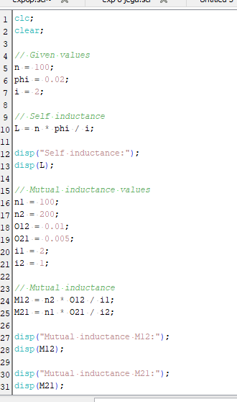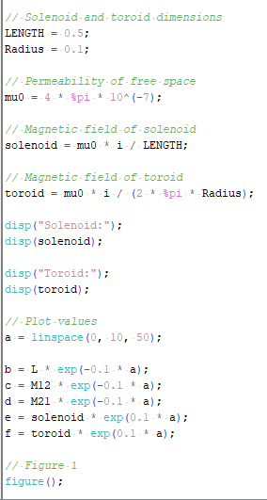
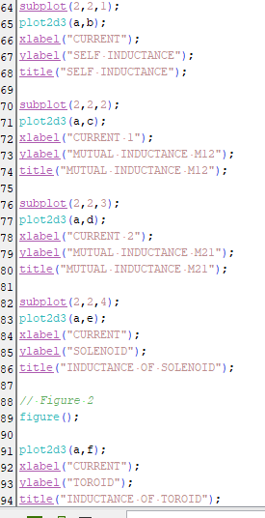
OUTPUT :
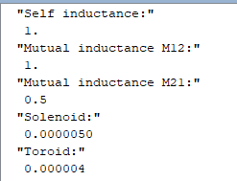
GRAPH :
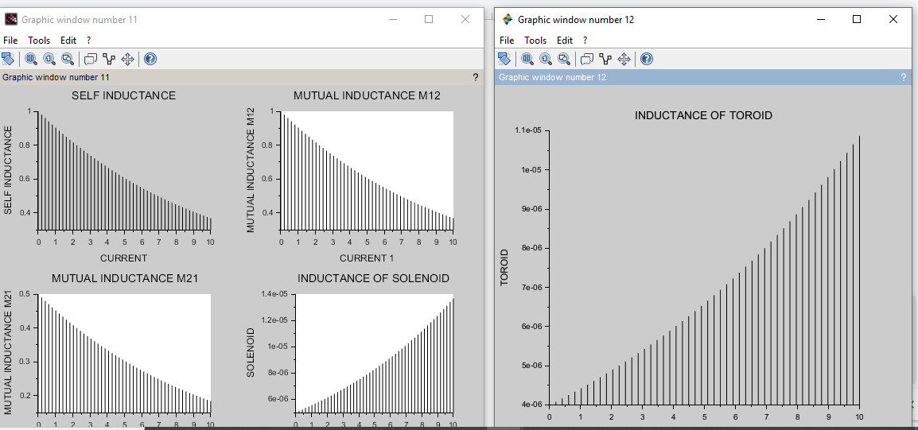
CALCULATIONS :
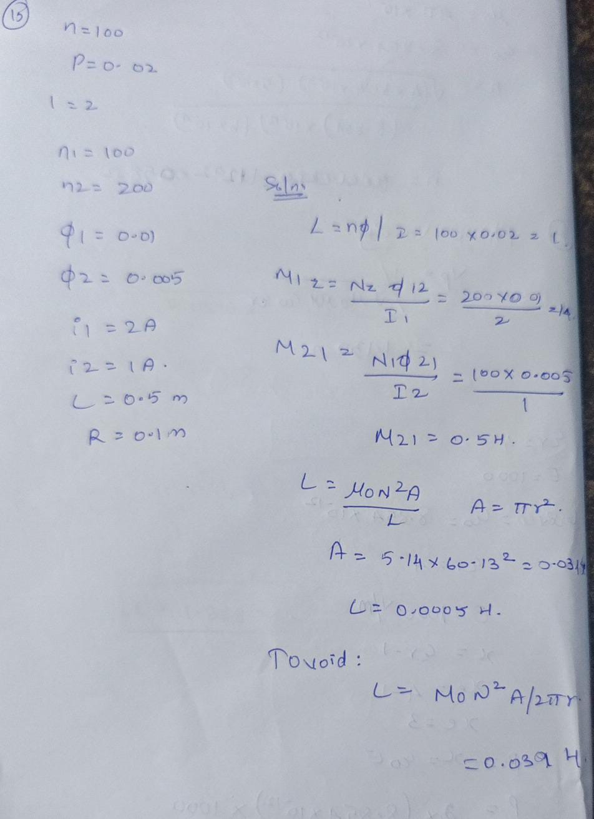

Result:
Thus determination and plotting of Inductance ,Self-inductance, Mutual inductance of current carrying coil, solenoid and toroid with different (a) length and (b) circumferential area
Are performed and verified successfully.

